Karile Levickaite
Discuss the case of Mrs. A in relation with UN standards on human rights (especially the CRPD) and of the 2008 Interim Report of the Special Rapporteur on Torture.

I. The decision to admit Mrs A involuntarily to a psychiatric ward of the general hospital for treating her manic episode was made without her informed consent, and she was furious about this decision. Well, Mrs A was involuntary hospitalized. After this she was involuntary treated, as she was not cooperative and angry during the treatment.
According to UN standards, this situation could be referred to the violation of the right to liberty, which is enshrined in the essential UN document - UDHR Article 3 “Everyone has the right to life, liberty and security of person“, also in relevant articles of CRPD:
- Article 3 entrenches general principles of respect of dignity, non-discrimination equal opportunities, which contradicts with the fact, that despite will of Mrs A, she was admitted and treated without her consent, which would not be possible in case of other nature of illness, e.g. pneumonia or cancer.
- Article 12 equal recognizes people with disabilities equally before the law with others and promotes safeguards to ensure measures for exercising legal capacity. In this case, the supported decision making mechanism was even not considered, despite the fact, the additional information should be needed to decide, if Mrs A would need such support.
- Article 14 states, that persons with disabilities, on an equal basis with others, which is not in the case of involuntary hospitalization and involuntary treatment. Also the existence of a disability shall in no case justify a deprivation of liberty, which clearly is the case in this story.
- Article 15 prohibits torture, or cruel inhuman and degrading treatment and punishment, which in this case is also relevant in some amount as Mrs A has to experience procedures against her will, which could lead to experiencing torture or cruel treatment.
In the Interim Report of the Special Rapporteur on Torture (2008) there are highlights regarding involuntary commitment to psychiatric institutions and forced psychiatric interventions. Not mentioning abovementioned references to the particular articles of CRPD, there is a clear reference to Convention against Torture. Assessing the pain inflicted by deprivation of liberty, the length of institutionalization, the conditions of detention and the treatment inflicted must be taken into account. I case of Mrs A, the torture was a major issue.
II. Involuntary treatment procedures like use of chemical and physical restrains in the situation of Mrs A clearly violated many UN principles including UDHR Article 5, Convention against Torture and Other Cruel, Inhuman or Degrading Treatment or Punishment, CRPD Article 15.
Once Mrs A was, admitted she was put under antipsychotic medication and sedated with high dosages of benzodiazepines. This was followed by restrain at her bed, which was removed every 12 hours for four days until her death very likely caused by the procedures of restraining. In conclusion severe form of physical restraint and overmedication as a form of chemical restraint, were applied in combination.
The Special Rapporteur on the Torture in his interim report (2008) notes, that prolonged use of restraint can lead to muscle atrophy, life-threatening deformities and even organ failure, and exacerbates psychological damage. The Special Rapporteur notes that there can be no therapeutic justification for the prolonged use of restraints, which may amount to torture or ill-treatment.
The Special Rapporteur on the Torture (2013) follows up on that and calls for absolute ban on restraints and seclusion stating, that any restraint on people with mental disabilities for even a short period of time may constitute torture and ill treatment.
Analyze how this case would be managed in your country
In Lithuania all form of restrains (mechanical physical and chemical), involuntary admission and involuntary treatment are not prohibited and in compliance with national regulation (Mental Health Act). Thus the case of Mrs A could be easily happening in Lithuania. I would like to introduce the real recent example.
Last week our NGO “Mental Health Perspectives” was approached by the mother of the son which learning disability, who lives in the closed social care institution. Due to acute phases of the illness, her son is admitted to the mental hospital from time to time. So happened recently. The mother visiting him in the hospital has found the restriction belt under his bed with written his name and family name on it. She complained, that her son is constantly restrained and did send us several pictures, also provided the agreed consent to public her story anonymously, which our organization is going to do. This story clearly demonstrates harm induced by prolonged the use of restrains.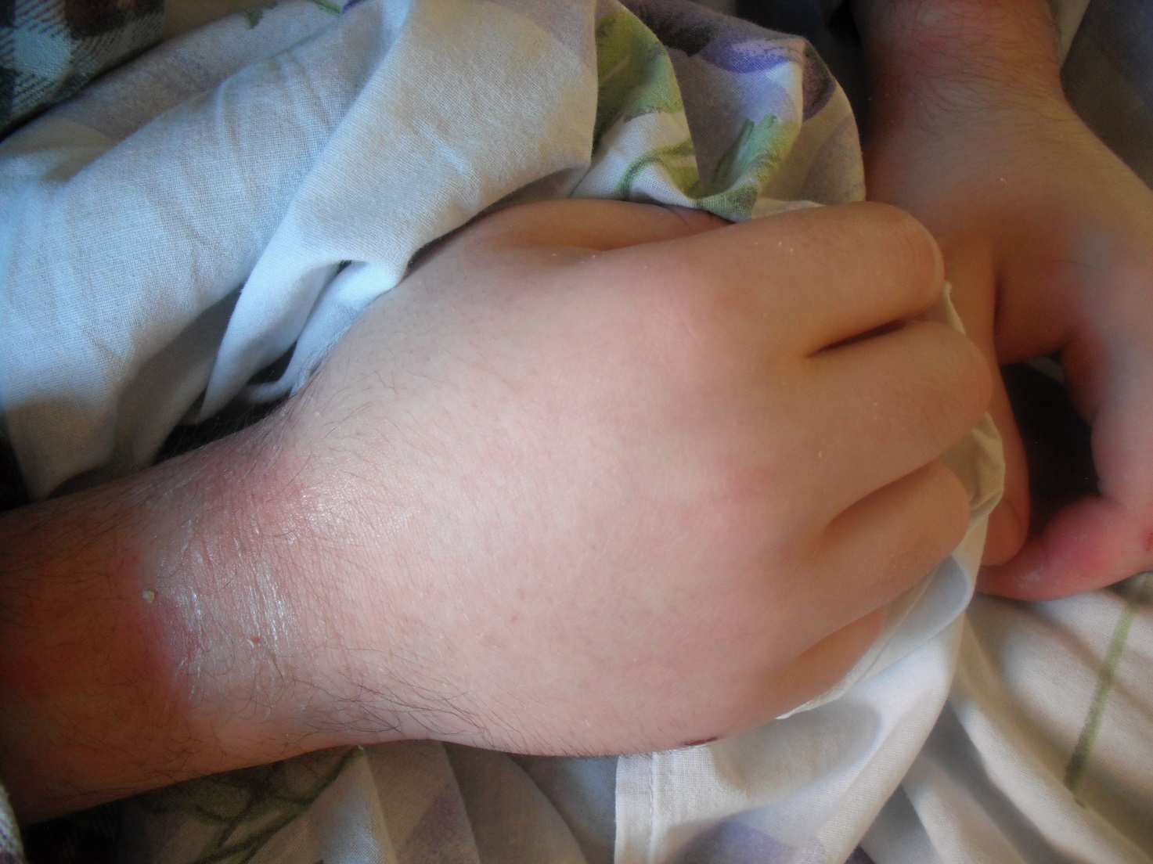
I analysed, that the social care home and, of course, the mental hospital have the licenses allowing to practice psychiatric treatment, which allows procedures of seclusion and restrain. But only internal documents of the institution include procedures of use, which are not enshrined in national legislation in detail. Therefore the case could be litigated after mothers reporting this evidence to the police, which is not within the interest of the mother, as her son has to live in the institution, which she would sue. Parliament Ombudsmen institution, which are national preventing monitoring institution in framework of implementation of OPCAT, were informed about this case with the reference to the particular social care institution hoping for future investigation. But this mechanism is not functioning very well, as many recommendations of Parliament Ombudsmen are often remained unimplemented.
In case of involuntary admission and treatment, there are very few possibilities for the person to complain too. The way would be similar: hiring private lawyer or informing the police.
Suggest possible changes in your country legislation about involuntary admission and treatment in order to better implement human rights issues raising from this case

Abandonment of regulations allowing involuntary admission and treatment, as well as use restrains and seclusion in Lithuania is not realistic, so possible changes in legislation could be discussed on the level of procedures on how to better implement human rights issues. CPT report (2012) includes following observations in summary.
Lithuanian legislation still does not provide for a distinction between involuntary admission and treatment without consent. People should, as a matter of principle, be placed in a position to give their free and informed consent to treatment. Every person, whether voluntary or involuntary, should be fully informed about the treatment which it is intended to prescribe and given the opportunity to refuse treatment or any other medical intervention.
Thus Lithuanian authorities should take steps including of a legislative nature to distinguish clearly between the procedure for involuntary placement in a psychiatric institution and the procedure for involuntary psychiatric treatment.
Lithuanian judges usually order involuntary hospitalization without ever having seen the patient concerned. In practice, their role is often limited to simply carrying out a formal check of the documents submitted by the Hospital’s administration. Moreover judges are not required to (and in practice never do) seek an opinion from a psychiatrist outside the hospital concerned during civil involuntary placement procedures.
There is recommended to change national legislation, that patients should have the effective right to be heard in person by the judge (for this purpose, consideration may be given to the holding of hearings on hospital premises). Also the court should always seek an opinion from a psychiatrist who is not attached to the psychiatric institution admitting the patient concerned.
Also outside of CPT recommendations, I would emphasize the need to establish the legal mechanism for referral of the cases related with rights violations of people with psychosocial disabilities, who are treated in social care or mental institutions – asylums.

